**ENGN2520 Homework 2**

**Ming Xu (Banner ID: B01532164)**

**Problem1**

Because x is a random variable with uniform distribution on [*a,b*], then the pmf of x is:

$p\left(x\right)=1/\left(b-a\right)$.

Therefore, the likelihood function $L$ on the training set $T$ can be written as:

$$L((a,b)|T) = P(T|(a,b))=\prod_{i=1}^{n}{p(x_{i}|(a,b)) = }\prod_{i=1}^{n}{\frac{1}{b-a} = {(\frac{1}{b-a})}^{n}}$$

Denote the log likelihood as $l((a,b)|T) = log L((a,b)|T) = -n*log(b-a)$

$$\left\{\begin{aligned}\frac{∂l((a,b)|T)}{∂a}=\frac{n}{b-a} \\ \frac{∂l((a,b)|T)}{∂b}=-\frac{n}{b-a}\end{aligned}\right.$$

According to the derivatives of the log-likelihood function, $\frac{∂l((a,b)|T)}{∂a}$ is monotonically increasing. Therefore, the maximum likelihood estimator for $a$ should be the largest possible of $a$.

$a = min(x_{i})$

Similarly, the derivatives of the log-likelihood function, $\frac{∂l((a,b)|T)}{∂b}$ is monotonically decreasing. Therefore, the maximum likelihood estimator for $b$ should be the largest possible of $b$.

$b = max(x_{i})$

**Problem2**

***(a)***

We know that: $w_{ML}=\underset{w∈R^{m}}{argmax}{L(w)}$

Let $x_{i}^{A}$ be the $ith$ sample from training set ***A***, and $x_{i}^{B}$ be the $ith$ sample from training set ***B***

The likelihood function $L(w)$ can be written as:

$$L\left(w\right)=\prod_{i=1}^{n}{P\left(y_{i}^{A} | x_{i}^{A},w\right)}*\prod_{i=1}^{n}{P\left(y_{i}^{B} | x_{i}^{B},w\right)}$$

$$=\prod_{i=1}^{n}{\frac{1}{\sqrt{2πσ_{A}}}exp\{-\frac{{(y_{i}^{A}-f_{w}(x_{i}^{A}))}^{2}}{2σ_{A}^{2}}\}}*\prod_{i=1}^{n}{\frac{1}{\sqrt{2πσ_{B}}}exp\{-\frac{{(y_{i}^{B}-f_{w}(x_{i}^{B}))}^{2}}{2σ_{B}^{2}}\}}$$

Denote the log likelihood as $l(w) = log L(w)$,

$$l(w)=\sum_{i=1}^{n}{(log}\frac{1}{\sqrt{2πσ_{A}}}-\frac{{(y_{i}^{A}-f_{w}(x_{i}^{A}))}^{2}}{2σ_{A}^{2}})+\sum_{i=1}^{n}{(log}\frac{1}{\sqrt{2πσ_{B}}}-\frac{{(y_{i}^{B}-f_{w}(x_{i}^{B}))}^{2}}{2σ_{B}^{2}})$$

$$w_{ML}=\underset{w∈R^{m}}{argmax}{l(w)}=\underset{w∈R^{m}}{argmin}{[\sum_{i=1}^{n}{\frac{{(y_{i}^{A}-f_{w}(x_{i}^{A}))}^{2}}{2σ_{A}^{2}}}}+\sum_{i=1}^{n}{\frac{{(y_{i}^{B}-f_{w}(x_{i}^{B}))}^{2}}{2σ_{B}^{2}}]}$$

$$=\underset{w∈R^{m}}{argmin}[\frac{1}{σ_{A}^{2}}*E_{A}\left(w\right)+\frac{1}{σ_{B}^{2}}*E_{B}\left(w\right)]$$

Where $E_{A}\left(w\right)$ is the sum of squared differences over training set ***A*** and $E_{B}\left(w\right)$ is the sum of squared differences over training set ***B.***

Therefore, $E\left(w\right)=\frac{1}{σ_{A}^{2}}*E_{A}\left(w\right)+\frac{1}{σ_{B}^{2}}*E_{B}\left(w\right)$

***(b)***

Because $E\left(w\right)=\frac{1}{σ_{A}^{2}}*E_{A}\left(w\right)+\frac{1}{σ_{B}^{2}}*E_{B}\left(w\right)$,

So we search for the w such that $∇E\left(w\right)=0$

This is equivalent to the set of equations $\frac{∂E(w)}{∂w_{j}}= \frac{1}{σ_{A}^{2}}*\frac{∂E_{A}(w)}{∂w_{j}}+\frac{1}{σ_{B}^{2}}*\frac{∂E_{B}(w)}{∂w_{j}}$

Since, for $\frac{∂E_{A}(w)}{∂w_{j}}$, the matrix ***M*** and vector ***Z*** are:

$$M_{k,j}^{A}=\sum_{i=1}^{n}{f_{k}(x_{i}^{A})}*f_{j}(x_{i}^{A})$$

$$Z_{j}^{A}=\sum_{i=1}^{n}{y_{i}^{A}}*f_{j}(x_{i}^{A})$$

Similarly, for $\frac{∂E_{B}(w)}{∂w_{j}}$, the matrix ***M*** and vector ***Z*** are:

$$M_{k,j}^{B}=\sum_{i=1}^{n}{f_{k}(x_{i}^{B})}*f_{j}(x_{i}^{B})$$

$$Z_{j}^{B}=\sum_{i=1}^{n}{y_{i}^{B}}*f_{j}(x_{i}^{B})$$

Combining the result above, the final matrix ***M*** and vector ***Z*** are:

$$M_{k,j}=\frac{1}{σ_{A}^{2}}M_{k,j}^{A}+\frac{1}{σ_{B}^{2}}M_{k,j}^{B}=\sum_{i=1}^{n}{\frac{1}{σ_{A}^{2}}f_{k}(x_{i}^{A})}*f_{j}\left(x_{i}^{A}\right)+{\frac{1}{σ_{B}^{2}}f}_{k}\left(x_{i}^{B}\right)*f_{j}(x_{i}^{B})$$

$$Z_{j}=\frac{1}{σ_{A}^{2}}Z_{j}^{A}+{\frac{1}{σ_{B}^{2}}Z}_{j}^{B}=\sum_{i=1}^{n}{{\frac{1}{σ_{A}^{2}}y}_{i}^{A}}*f_{j}\left(x_{i}^{A}\right)+\frac{1}{σ_{B}^{2}}y_{i}^{B}*f_{j}(x_{i}^{B})$$

Therefore, $w_{ML}$ can be computed by solving the linear system.

***(c)***

From the mathematical model above, they shouldn't ignore Bob's measurements in estimating their function. They can incorporate by combining their test results using a weighted sum method.

***(d)***

If we don't know the $σ_{A}$ and $σ_{B}$, we can suppose $σ_{A}=σ_{B}$. Then use the mean of $M_{k,j}^{A}$ and $M_{k,j}^{B}$ to calculate $M_{k,j}$, and use the mean of $Z_{j}^{A}$ and $Z_{j}^{B}$ to calculate $Z_{j}$.

**Problem3**

***(a)***

The degree 2 polynomials that estimated by least square regression and least absolute deviations regression are shown in the figure below.

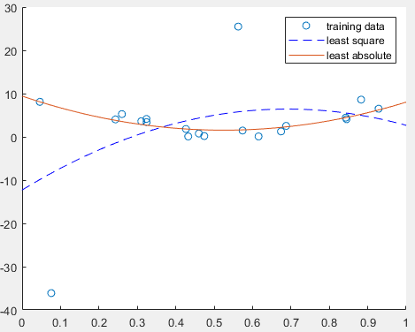

Fig.1. The degree 2 polynomials that estimated from training data

In the figure, the orange solid line indicates the degree 2 polynomials estimated by least absolute deviations regression, while the blue dash line indicates the degree 2 polynomials estimated by least square regression.

***(b)***

The degree 4 polynomials that estimated by least square regression and least absolute deviations regression are shown in the figure below.

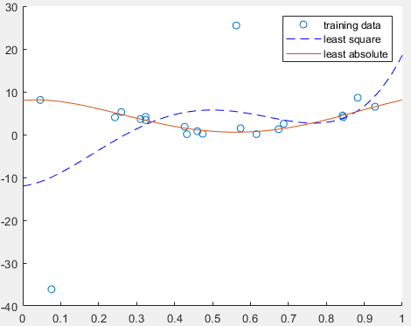

Fig.2. The degree 4 polynomials that estimated from training data

In the figure, the orange solid line indicates the degree 4 polynomials estimated by least absolute deviations regression, while the blue dash line indicates the degree 4 polynomials estimated by least square regression.

***(c)***

Based on the given experiments, least absolute deviations regression is more robust than the least square regression when outliners exist.

***(d)*** Source code

1. Function to calculate w from training set by least square regression: “solveW.m”

function [w] = solveW(x,y,deg)

%initialization

M = zeros(deg+1,deg+1);

Z = zeros(deg+1,1);

%contruct matrix M

for row = 1:deg+1

for col = 1:deg+1

M(row,col) = sum((x.^(row-1)).*(x.^(col-1)));

end

end

%construct matrix Z

for row = 1:deg+1

Z(row,1) = sum(y.*(x.^(row-1)));

end

%calculate w

w = M\Z;

end

2. Function to calculate fx by giving x and w: “calculateFxByGivingW.m”

function [fx] = calculateFxByGivingW(x,w)

%get degree

[deg, col] = size(w);

%get size

[rowNum, col] = size(x);

%initialize fx

fx = zeros(rowNum, col);

%calculate fx by usuing polynomial function defined by w

for row = 1:rowNum

for i = 1:deg

fx(row,1) = fx(row,1) + w(i)*x(row,1)^(i-1);

end

end

end

3. Function to calculate w from training set by least absolute derivations regression: “solveWByLinearProgramming.m”

function [w] = solveWByLinearProgramming(x,y,deg)

%get size

[rowNum, col] = size(x);

deg = deg + 1;

%initialization

A = zeros(2*rowNum, rowNum+deg);

b = zeros(2*rowNum,1);

C = zeros(1,rowNum+deg);

%generate C

index = deg+1:rowNum+deg;

C(index) = 1;

%generate b

index = 1:2:2*rowNum-1;

b(index) = y;

index = 2:2:2*rowNum;

b(index) = -y;

%generate A

for row = 1:2:2*rowNum-1

for col = 1:deg

A(row,col) = x(ceil(row/2),1).^(col-1);

end

A(row,deg+ceil(row/2))=-1;

end

for row = 2:2:2*rowNum

A(row,:) = -A(row-1,:);

A(row,deg+ceil(row/2))=-1;

end

%calculate w by linear program

result = linprog(C,A,b);

w = result(1:deg);

end

4. Main function: “main.m”

%loal data

load Xtrain

load Ytrain

%plot showing the training data and degree 2 polynomial estimated from the

%data

w1 = solveW(Xtrain,Ytrain,4);

w2 = solveWByLinearProgramming(Xtrain,Ytrain,4);

scatter(Xtrain,Ytrain,'DisplayName','training data');

hold on;

x = 0:0.01:1;

x = x';

fx1 = calculateFxByGivingW(x,w1);

fx2 = calculateFxByGivingW(x,w2);

plot(x,fx1,'b--','DisplayName','least square');

plot(x,fx2,'DisplayName','least absolute');

legend;